

A Parent/Carer’s Guide to Microsoft Teams
Microsoft Teams is a digital platform that lets teachers keep in touch with children remotely. Children can access support from their class teacher and use apps such as Word and PowerPoint from home. All of this can be accessed by your child by simply logging into Microsoft Teams using the email and password that has been sent home.
Microsoft Teams is a safe and secure environment that lets teachers communicate with pupils, share files, videos and useful websites and give feedback directly to the pupils. There is also a function to schedule safe, secure Live Lessons for children in the class, or with smaller groups of children. (For further information on this, please refer to the Remote Learning Policy, Safeguarding Policy, Acceptable Usage Policy and GDPR Policy). Lumbertub’s staff will use Microsoft Teams for remote learning during whole class isolation/closure.

Sign in methods: (Separate, more detailed, instructions have been sent – Parent and pupil instructions for accessing Teams )
1. teams.office.com (Web Browser) You will be asked to sign in to Teams. Sign in using your child’s school email address and password that has been provided. Please keep the log-in information safe in case you are logged out for any reason. Once you have signed in, you may be asked to download the app to use Teams in the future. You are responsible for protecting your child’s password. If you do not want to download the app, there is the option to open teams using the web app instead.
2. Teams App (Desktop computer, laptop, tablet etc.) You can download the Teams App on to your computer, laptop, phone or tablet. This makes it quicker and simpler to log in and has more functions than using the web app. Again, sign in using your child’s school email address and password that has been provided.
3. PS4 or Xbox (refer to Parent and Pupil Guide for accessing Microsoft Teams)

Finding Your Way Around Microsoft Teams
My Teams
Once your child has logged in to Teams, they will be able to see their class which has been premade for them. Essentially, the word “Team” is just another word for “Class” or “Group”.

Post/Activities (Named differently according to what device you are using but are the same thing)
Here you can see any posts (messages) from teachers, announcements linked to that day with details of lessons and any resources to help your child.
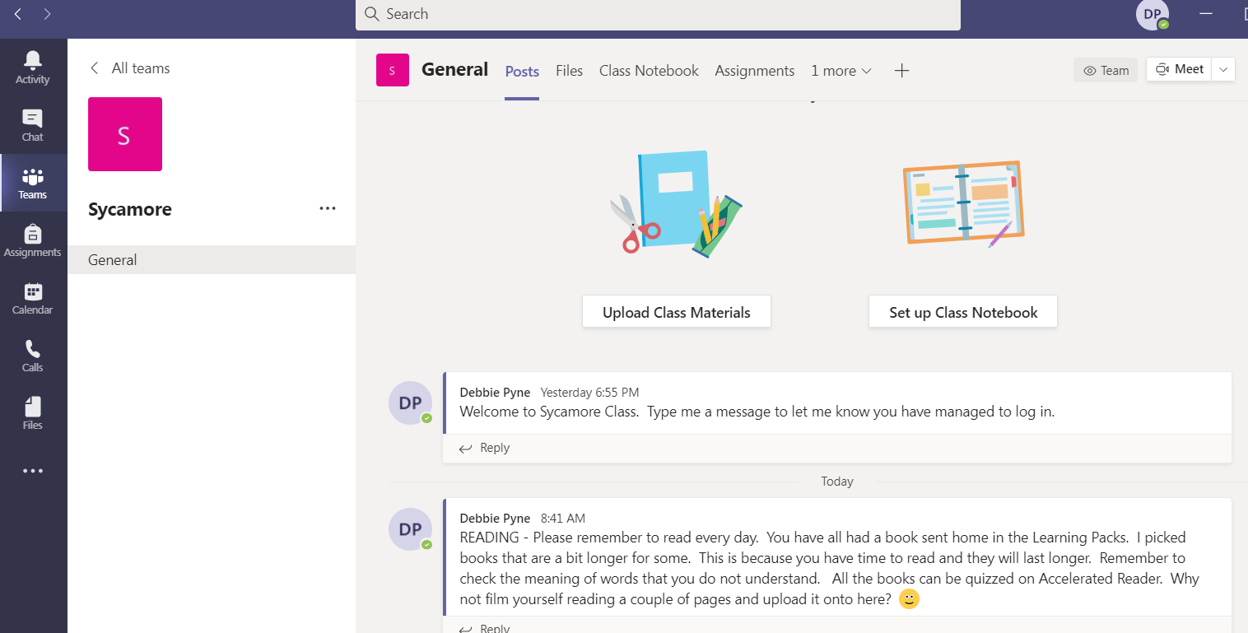

Files
When you click on files, you will be able to see any resources that have been uploaded to help your child with their remote learning. There may be worksheets to complete, videos to watch or materials to read.
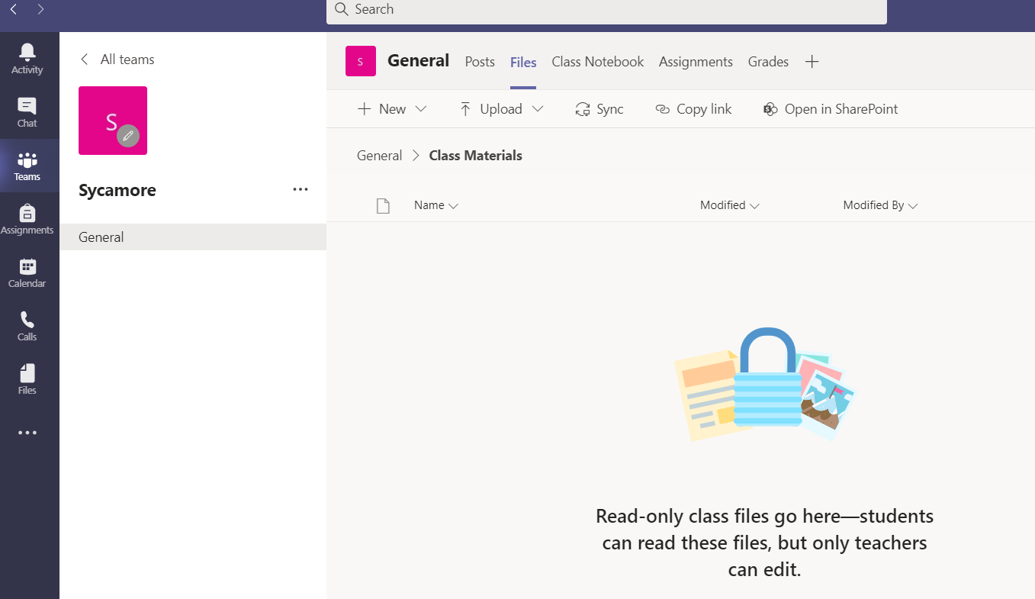

Assignments
Teachers will set assignments (home learning) for the pupils in the class through Teams. Click the “Assignments” tab to see if anything has been set for you. Follow the instructions on the assignment to complete work and submit it back to the teacher. The teacher can then give feedback for this work. Only the class teacher will be able to see your work. You will receive a notification on Teams to tell you when work has been seen by the class teacher.
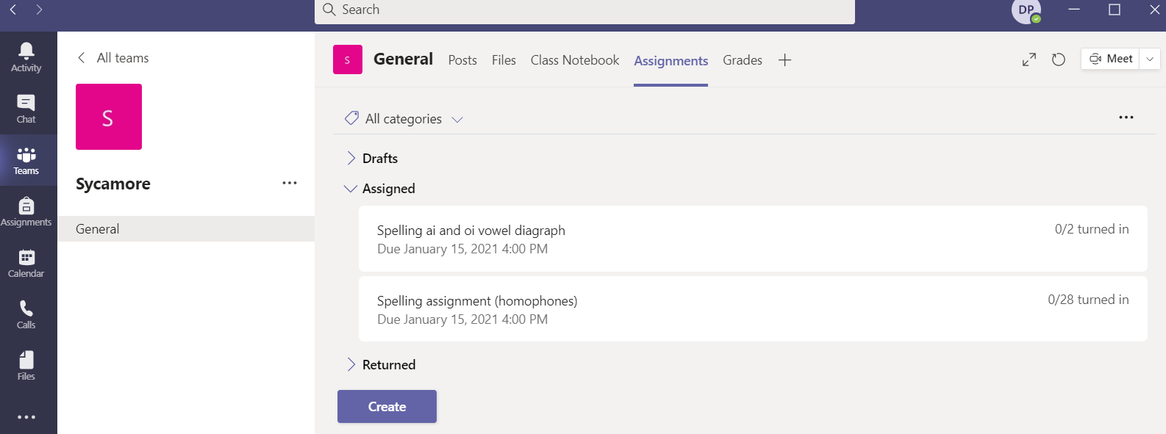

Live Lessons
Teachers will be able to communicate with pupils using the inbuilt video conferencing system on Microsoft Teams. Within the Team, the teacher can set Live Lessons for pupils to join. The meetings will be determined by the teacher at a specific time and date. Pupils will be instructed to join the meeting by clicking the “Join” button that will appear on the “calendar” section. The children may need to wait in a lobby and the teacher will admit them at the start of the lesson.
Once you have joined the call, we ask that the children turn on their camera and turn the microphone to mute, the teacher will ask children to unmute themselves if needed during the session. There is also a function that allows you to raise your “virtual hand” if you want to answer a question but you can also use this if you need any assistance.
Please note that if children join using an Xbox or PS4, they will be able to see and hear the teacher. The teacher will know that your child is in the ‘class’ but will not be able to see your child. They will be able to hear your child.

Private Chat
Please note that private chat functions have been disabled for the children. All communication on Teams is monitored by staff. Children should only use Teams to communicate with teachers during school hours.

More Information
For more information on rules and expectations for Live Lessons, please refer to the Lumbertubs Remote Learning Policy.

Mrs Pyne
ICT Coordinator
January 2021

